Project Design Phase-II
Technology Stack (Architecture & Stack)

Date
Team ID | Team 12
Project Name | Smart library request workflow
Maximum Marks | 4 Marks

Technical Architecture:
The Smart Library Request Workflow uses cloud-based services to process user requests submitted via audio or text, converting them into structured data using speech recognition and natural language understanding.
The processed data is stored in a database and accessed

Order processing during pandemics for offline mode:
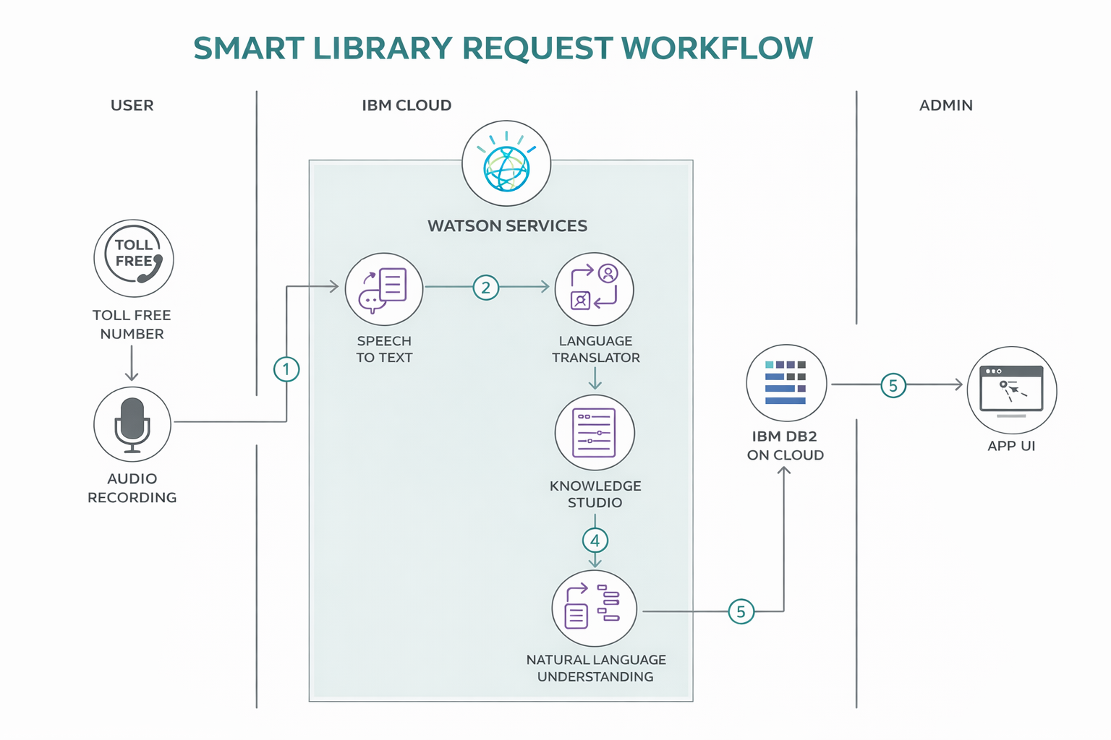

Table-1 : Components & Technologies:
S.No | Component | Description | Technology
 | User Interface | Interface for users to request and track books | HTML, CSS, JavaScript / React / Angular
 | Application Logic-1 | Handles request processing and user management | Python / Java
 | Application Logic-2 | Converts speech to text | IBM Watson STT
 | Application Logic-3 | Processes user queries intelligently | IBM Watson Assistant
 | Database | Stores users, books, and requests | MySQL / MongoDB
 | Cloud Database | Cloud-based data storage | IBM DB2 / Cloudant
 | File Storage | Stores files and documents | Cloud Storage / Local
 | External API-1 | Fetches book details | . Google Books API
 | External API-2 | Provides notifications/verification | SMS / Email API
 | Machine Learning Model | Recommends books | ML Model (Python)
 | Infrastructure (Server / Cloud) | Deploys application | Cloud / Kubernetes

Table-2: Application Characteristics:
S.No | Characteristics | Description | Technology
 | Open-Source Frameworks | Used for building UI and backend services | React JS, Node.js, Flask
 | Security Implementations | Ensures secure data access and user authentication | HTTPS, SHA-256, JWT, IAM Controls
 | Scalable Architecture | Supports increasing users using modular design | Microservices, Cloud (IBM Cloud / AWS)
 | Availability | Ensures system is always accessible | Load Balancer, Cloud Servers
 | Performance | Improves speed and handles multiple requests efficiently | Caching, CDN, Optimized APIs

